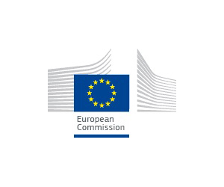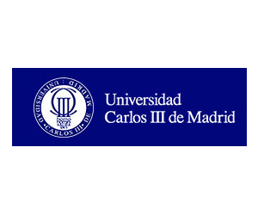
Program - Seminar DIADSE project: Labour Law Reforms and Social Dialogue in the EU
12.02.2016
University Carlos III-Madrid
Salón de Actos Campus Puerta de Toledo, Madrid

8.45-9.20 - Registration
9.20 - Opening and Introductory Words
- 'DIADSE project in overview: labour law reforms and labour market trends in Europe' - Prof. Dr. Evert Verhulp, University of Amsterdam;
- ‘The system of Collective Bargaining in Spain’ (in Spanish) -
Prof. Dr. Jesús R. Mercader Uguina, University Carlos III-Madrid;
10.15 - The Reform of Labour Market Legislation - key features and implementation Chair: Ana Belén Muñoz
- ‘The case study on Spain’ Prof. Dr. Francisco Javier Gómez Abelleira, Univ. Carlos III-Madrid
- ‘The application of the Labour Law Reform: Dismissal’ - Román Gil, Sagardoy Abogados;
- ‘The Labour Law Reform in Practice’ - Fermín Guardiola, Baker & Mckenzie;
11.30 – Coffee Break
11.50– Round Table: The Position of the Social Partners on the Labour Law Reform and Last Development in Social Dialogue (in Spanish), Chair: Jesús Mercader Uguina
Isidor Boix, CCOO (Social Dialogue in Spain)
Ana I. Herráez Plaza, CEOE (Social Dialogue in Spain)
Bernardo García, UGT (Social Dialogue in Spain)
12.50 – Structural Reforms in the Shadow of the Troika – the cases of Ireland and Portugal – Chair: Manuel Abrantes, CESIS
- Robert Mooney – Ireland,
- Maria do Paz Lima, CESIS – Portugal,
13.35 – Lunch Break
15.00 – Parallel Workshops – The DIADSE case studies:
Worshop I (room 0.A.01): Undertaking Reforms in corporatist systems – the case studies of the Netherlands and Belgium, Rapporteur: Evert Verhulp -
- Robert Knegt, University of Amsterdam – the Netherlands
- Alexander de Becker, University of Hasselt – Belgium
Worshop II (room 0.A.03): (Re)-building Social Dialogue Structures – The Central and Eastern Europe case – Rapporteur: Dr. Maria do Paz Lima -
- Miroslaw Wroblewski- Ombudsman Poland
- Attila Kun, University of Budapest - Hungary
Workshop III (room O.A.04):The Forerunners and the slow-motion process – Confronting the reforms in Germany and France – Rapporteur: Ana Belén Muñoz -
- Esther Koot, CAO/Recht – Germany
- Nuria Ramos Martín, University of Amsterdam – France

15.55 Coffee break
16.10 Plenary – Discussion of the Conclusions of the Workshops - Rapporteurs Prof. Evert Verhulp, Dr. Maria do Paz Lima and Ana Belén Muñoz.
16 .55 – Round Table: Trends in Social Dialogue in Europe – Chair: Nuria Ramos Martín
- Dr. Philippe Pochet – Director of the ETUI
- Maxime Cerutti - BUSINESSEUROPE Director for Social Affairs
- Prof. Dr. Klara Boonstra, Free University of Amsterdam/FNV senior legal expert
18.10 – Closure – Prof. Evert Verhulp and Prof. Jesús Mercader Uguina

Organising Committee:
Prof. Jesús Mercader Uguina
Prof. Evert Verhulp
Prof. Francisco Javier Gómez Abelleira
Dr. Nuria Ramos Martín
Dr. Ana Belén Muñoz Ruiz
Dr. Pablo Gimeno Díaz de Atauri
Dr. Daniel Pérez del Prado
International Research Project DIADSE (Dialogue for Advancing Social Europe)

DIADSE event - Project financed by EU, European Commission DG Employment, Social Affairs and Inclusion, Social Dialogue, Industrial Relations (Agreement number. VS/2014/0530) Duration: December 2014 – December 2016. Project Management: Universiteit van Amsterdam (Hugo Sinzheimer Institute) Coordinators: Prof. Dr. Evert Verhulp and Dr. Nuria. E. Ramos Martín

Disclaimer excluding Commission responsibility
This event related to the action DIADSE is made by the beneficiaries and it reflects only their views. The Commission is not responsible for any use that may be made of the information it contains.

